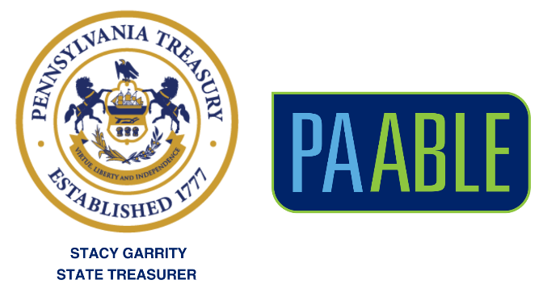

PA ABLE Social Media Toolkit

The Pennsylvania ABLE Savings Program (PA ABLE), gives individuals with qualified disabilities, and their families and friends, a way to save for disability-related expenses with significant tax benefits, while maintaining access to important benefits.

This toolkit provides messaging and information to share on your social media channels about the benefits of PA ABLE accounts.

The following pages include a number of suggested social media posts, along with links to the Pennsylvania Treasury Department’s official social media pages.

If you have questions or need additional resources (e.g., different-sized logos), please contact PA ABLE at info@paable.gov.

Thank you for supporting PA ABLE!

Suggested Messages

Post 1

Facebook

@Pennsylvania Treasury’s PA ABLE Savings Program continues to be one of the fastest-growing #ABLE programs in the nation – giving Pennsylvanians with disabilities and their families a great way to save for the future. paable.gov

Instagram

@patreasury’s PA ABLE Savings Program continues to be one of the fastest-growing #ABLE programs in the nation – giving Pennsylvanians with disabilities and their families a great way to save for the future. paable.gov

Twitter (X)

PA ABLE, overseen by the @PATreasurer, continues to be one of the fastest-growing #ABLE programs in the nation – giving Pennsylvanians with disabilities and their families a great way to save for the future. paable.gov

LinkedIn

@Pennsylvania Treasury’s PA ABLE Savings Program continues to be one of the fastest-growing #ABLE programs in the nation – giving Pennsylvanians with disabilities and their families a great way to save for the future. paable.gov

Post 2

Facebook

PA ABLE accounts are powerful tools to help people with disabilities save for a secure financial future and to live more independently. @PA Treasurer Stacy Garrity has reduced PA ABLE fees multiple times to help account owners save even more for their disability-related expenses. Learn more at paable.gov

Instagram

PA ABLE accounts are powerful tools to help people with disabilities save for a secure financial future and to live more independently. Treasurer Stacy Garrity (@patreasury) has reduced PA ABLE fees multiple times to help account owners save even more to cover the costs of their disability-related expenses. Learn more at paable.gov

Twitter

To help PA ABLE account owners save even more to cover the cost of disability-related expenses, @PATreasurer Stacy Garrity has reduced PA ABLE fees multiple times. Learn more at paable.gov

LinkedIn

PA ABLE accounts are powerful tools to help people with disabilities save for a secure financial future and to live more independently. Treasurer Stacy Garrity (@Pennsylvania Treasury) has reduced PA ABLE fees multiple times to help account owners save even more for their disability-related expenses. Learn more at paable.gov

Additional Posts

All Platforms

PA ABLE accounts can be used to save for day-to-day living costs and long-term disability-related expenses, plus much more. Learn more about qualifying expenses at paable.gov

PA ABLE allows people with disabilities and their families to have greater control of their finances and to plan for a more secure future without impacting eligibility for important benefits. Learn more at paable.gov

With PA ABLE, individuals can save for wheelchairs, assistive technology, and Braille readers. They can also save for community college, rent, a new bike, home repairs, and so much more. Learn more at paable.gov

Account owners can use PA ABLE funds to fulfill dreams and to meet everyday needs like education, housing, transportation, employment training or support, health, prevention, wellness and more. paable.gov

PA ABLE accounts help individuals with disabilities to save, regardless of the type of disability. This includes intellectual, physical, and psychological disabilities. Learn more at paable.gov

Anyone can make contributions to a PA ABLE account to help a loved one with a disability save for their future. Learn more at paable.gov

Treasury’s Official Social Media Pages
- Facebook (Primary): https://www.facebook.com/PATreasurerGarrity/
- Facebook (Institutional): https://www.facebook.com/PATreasurer
- Twitter (X): https://twitter.com/PATreasurer
- Instagram: https://www.instagram.com/patreasury/
- LinkedIn: https://www.linkedin.com/company/pennsylvania-state-treasury/

